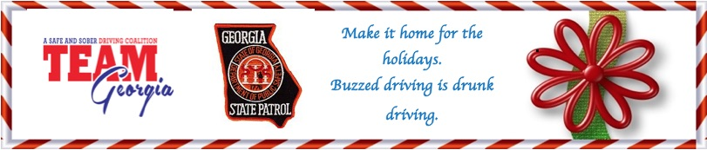
NEWS RELEASE Contact: Bob Cucchi
For immediate release TEAM Georgia
770-490-1243
cucchira@bellsouth.net
State and Local Officials join sober driving coalition for holiday message
(ATLANTA) – If you plan to enjoy the holidays with a drink, the Georgia State Patrol and TEAM Georgia have a message for you…drive sober or get pulled over. The two organizations are once again coming together for their end-of-year holiday campaign to help prevent impaired driving during Christmas and New Year’s. This year the Smyrna Police Department is joining in our safe holiday program.
TEAM Georgia is a sober driving coalition comprised of government and community leaders who urge businesses and private party hosts to make the safety of their guests the reason for the season. They are asked to encourage designated drivers and provide sober ride contact information for taxi services, the GOHS sober ride app.—Drive Sober, Georgia”, corporate programs like AAA’s Tow To Go and Checker Cab’s free holiday rides. The coalition’s messaging during high drinking holidays like Christmas/New Year’s and St. Patrick’s Day also underscore the legal ramifications of over-serving or not driving sober.
Unfortunately, Georgia Highway Safety data continues to show that impaired driving messaging during this holiday season is needed. Last year, both alcohol-related crashes and injuries were up, while non-alcohol-related crashes remained the same. But even a single alcohol-related death is one too many and entirely preventable.
“While Georgia experienced its first annual increase in traffic fatalities in nearly a decade in 2014, crashes, injuries and fatalities were also up in 2014 specifically during the holiday travel period from Dec. 23 through Dec. 31. For the travel period, crashes increased by 24 percent, injuries by 31 percent and fatalities by 39 percent from 28 in 2014 to 39 in 2015. Data from 2015 also shows similar increases.
"Holidays are for family gatherings and celebratory purposes,” said TEAM Georgia Chairman Ron Fennel. “Please help us avoid having families gather for funerals caused by drunk driving crashes. Join us in working to designate a driver and provide free rides for those who need one. This festive time of year should be when we are extra careful and responsible in the use of alcohol and travel. We wish for all Georgia motorists to have a safe holiday this year!"
For more information on TEAM Georgia, visit http://www.teamgeorgia.net/. For more information on impaired driving initiatives, visit www.gahighwaysafety.org. (END RELEASE)

