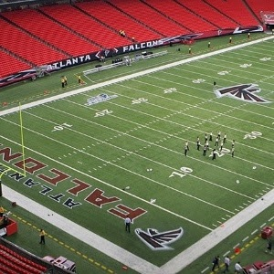
Atlanta Falcons Eliminated in the TEAM Coalition Responsibility Bowl by the Kansas City Chiefs
The Atlanta Falcons were eliminated somewhat decisively by the Kansas City Chiefs last weekend in the 2015 TEAM Coalition Responsibility Bowl. We should take heart in the fact that the Chiefs have more designated drivers signed up to date than any other NFL team this season. Losing to the eventual winner of the entire competition has some consolation, but we are still dealing with the psychological impact of this loss.
Going forward, our goal this season must now be to sign up more designated drivers than any other NFC team. Presently we are ahead of Seattle, but we cannot take their program for granted as we move into the final half of the season. (Additionally, their numbers do not include their 6th game totals for the season. Our totals do.)
Please check out the links below for more graphic information on the 2 programs mentioned above.
2015 NFL Designated Driver Standings
Responsibility Bowl Matchups
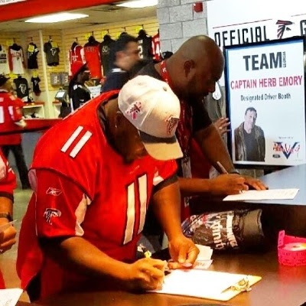
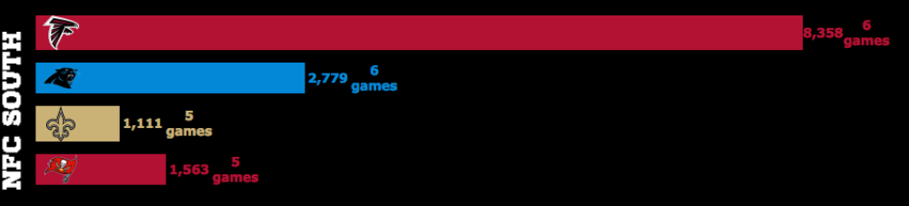

Copyright © 2015 TEAM Georgia, All rights reserved.

Want to change how you receive these emails?
You can update your preferences or unsubscribe from this list

This email was sent to christineherro1220@gmail.com
why did I get this? unsubscribe from this list update subscription preferences
Team Georgia · 233 Peachtree Street NE, Suite 1400 · Atlanta, GA 30303 · USA

